水问题论坛——2023年第23回（总第420回）

报告题目：AI-empowered Cross-scale Sensing for Climate-smart Agriculture
报告人：王盛 博士
主持人：刘苏峡 研究员
时间：2023年10月19日（星期四）下午15:00-17:30
地点：地理资源所A座九层A901会议室
报告人简介：
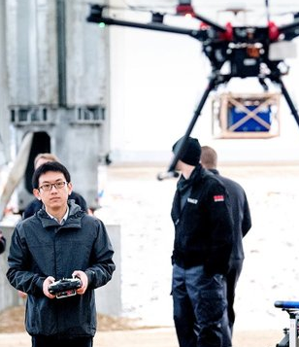
王盛, 丹麦奥尔胡斯大学助理教授，美国伊利诺伊大学厄巴纳-香槟分校兼职研究助理教授。2019年博士毕业于丹麦科学技术大学，2015年硕士毕业于中国科学院地理资源所和哥本哈根大学。主要从事空天协同遥感、可持续农业和生态水文等方面研究。共发表研究论文四十余篇，其中以第一或通讯作者在Remote Sensing of Environment，ISPRS Journal of Photogrammetry and Remote Sensing和Hydrology and Earth System Sciences等刊物发表十余篇。主持或共同主持美国农业部和欧盟等项目十项。曾获得国家优秀自费留学生奖学金、丹麦科学技术大学青年科学家、北京市和中科院优秀毕业生等荣誉。

报告内容简介：
Climate-smart agriculture requires an integrated approach to monitor, model, and optimize management practices to reduce greenhouse gas emissions to ensure the co-sustainability of food production and environmental quality. Timely and high-resolution agriculture data are essential for measuring, reporting, and verifying climate-smart agriculture implementation. However, conventional agricultural data collection through field sampling, laboratory analysis, and/or grower surveys is time-consuming and costly, which further limits the interpretation of large-scale satellite data. To address this challenge, we developed an artificial intelligence-empowered cross-scale sensing framework to integrate proximal, airborne, and spaceborne data to scalably upscale agriculture field measurements to every field in Illinois and beyond. This cross-scale sensing framework can accurately detect climate-smart agriculture-related variables, e.g., crop characteristics, tillage practices, cover crops, and soil organic carbon. We highlight that hyperspectral data from proximal, airborne, and new/forthcoming spaceborne missions provide high potential to empower agricultural monitoring and assessment across scales to support food security and environmental sustainability.

